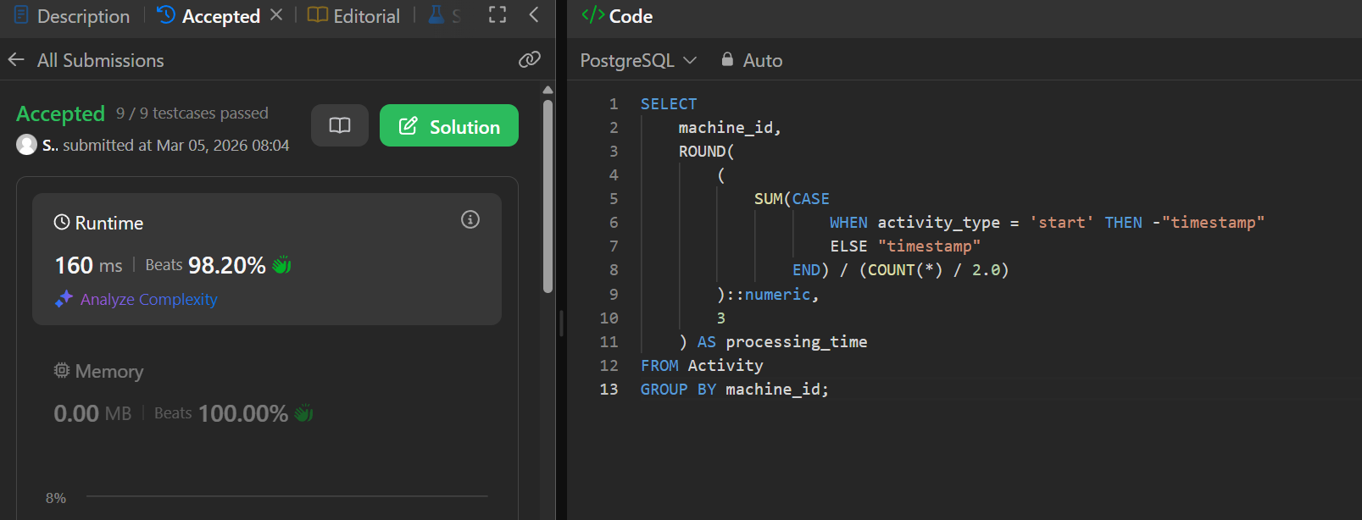

Qurerry-
SELECT
machine_id,
ROUND(
(
SUM(CASE
WHEN activity_type = 'start' THEN -"timestamp"
ELSE "timestamp"
END) / (COUNT(*) / 2.0)
)::numeric,
3
) AS processing_time
FROM Activity
GROUP BY machine_id;

